P.4 SCIENCE LESSON NOTES FOR 2024

CLASSIFICATION OF PLANTS

PLANTS

Flowering Plants Non-Flowering Plants

|  |  |
| --- | --- |
|  |  |
|  |  |
| roducing Conifers ( | |

Monocots Dicots Spore P

Seed Producing)

Non flowering plants

PLANT LIFE

1. What are non-flowering plants?

• Non flowering plants are plants that do not bear flowers conifers

• fir

• cedar

• pines

• cypress

• spore producing

• ferns

• mosses

• liverworts

• horsetails

FLOWERING PLANTS

Flowering plants are plants that bear flowers

EXAMPLES OF FLOWERING PLANTS

• Bean plant

• Peas plant

• Maize plant

• Groundnuts plant

• Millet plant

• rice plant etc.

Parts of a flowering plant.

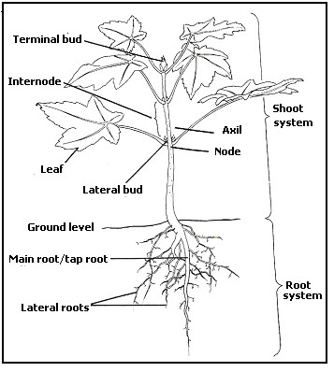

SYSTEMS OF A FLOWERING PLANT

2. The flowering plant has two systems namely:

a) Shoot system b) Root system

Root system.

Part of the plant that grows downward into the soil.

Parts of the root system

• Tap root

• Root cap

• Root hair

• Lateral roots

ROOTS

1.This is the part of a plant which grows in the soil.

2. A true root system develops fromthe radicle of the embryo. Importance of roots to plants

• Roots hold the plant firmly into the soil.

• Roots absorb water and mineral salts from the soil.

• Some plants store food for the roots. E.g. cassava roots, sweet potato roots, carrot roots etc.

Importance of roots to man

a) Some roots provide man with food. e.g. Cassava, Sweet potatoes and

Carrots.

b) Some roots are used as herbal medicine. c) Some roots are used to make craft items. d) Roots are used as wood fuel

e) Some roots are sold to get money

Note:

Roots that store food are called root tubers. Types of roots

o primary roots

o secondary roots

PRIMARY ROOTS

What are primary roots?

Primary roots are roots that develop from the radicle.

EXAMPLES OF PRIMARY ROOTS

• Tap root

• Fibrous roots

TAPROOT

These are roots from which lateral roots develop

Structure of a tap root

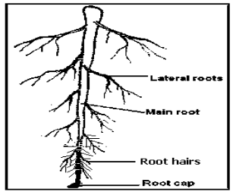

Examples of plants with tap roots a) Bean plants

b) Soya

c) Ground nuts d) Mango trees e) Tomatoes

f) Guava tree

Functions of parts of roots a. Root hair

To absorb water and mineral salts b. Root cap

To protect the tip of the root. c) Lateral root

Holds the plant into the soil

NOTE

Primary roots are divided into two root systems

• Taproot system

• Fibrous root system

Activity

Draw the root systems above

Fibrous roots

o This is a type of root system where there are many roots growing randomly.

• . There is no main root.

o They don’t go deep into the ground. Structure of fibrous roots

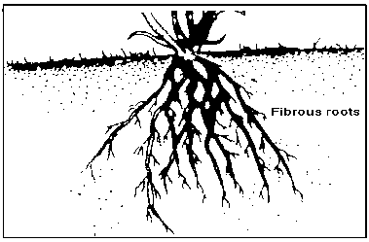

Examples of plants with fibrous roots

• Maize

• Sorghum

• Sugar cane

• Millet

• Rice.

• Wheat.

• Oats.

Secondary roots

These are roots that develop from the stems or leaves of a plant

Secondary roots are subdivided into two:

• Adventitious roots

• Aerial roots

AERIAL ROOTS

These are roots that appear above the ground e.g.

• Prop roots

• Clasping roots

• Buttress roots

• Stilt roots

• Breathing roots

PROP ROOTS

1. They develop from nodes near the ground level.

What is the main function of prop roots?

These are roots which give extra support to plants. Examples of plants with prop roots:

• Maize

• Sorghum

• Sugar cane

• millet

• rice

• wheat

• elephant grass etc. Structure of prop roots

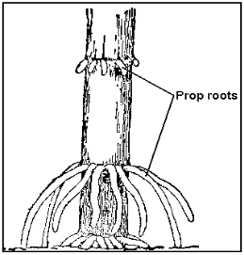

Storage roots/ Root tubers

These are swollen underground roots with stored food. Examples of storage roots:

• Cassava

• Sweet potatoes

• Carrots

• beet root

• root turnip

• Swedes

• sugar beet

• white yams

• parsnips

• dahlia

Structures of storage roots

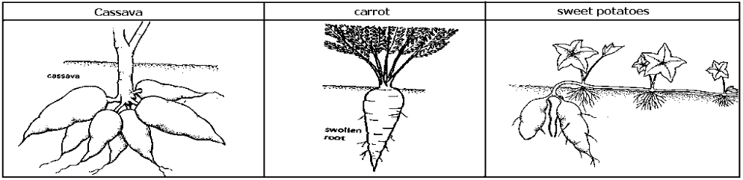

Shoot system

1.Part of the plant that grow above the ground.

Parts found on the shoot system.

|  |  |  |  |
| --- | --- | --- | --- |
| • | Stem, | • | Fruit, |
| • | Leaves, | • | Flower, |
| • | Lateral buds, | • | Node. |
| • | Terminal bud, | • | Internodes |

THE LEAVES OF A PLANT Parts of a leaf

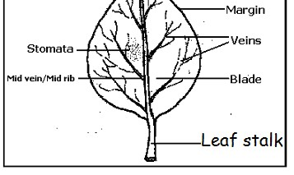

Functions of some parts of a leaf

Mid vein

• Transports water and mineral salts from the leaf stalk to the leaf.

• Transports starch from the leaf to the leaf stalk.

Veins

• Distributes water and mineral salts in the leaf

Leaf stalk

Transports starch to the lower parts of the plant

• Transports water to the leaf.

• It attaches the leaf to the stem

Stomata

• It is used for breathing.

• It helps in transpiration

LAMINA Makes food

Uses of leaves to a plant

• Leaves make starch

o Plants store food in leaves

• Leaves help the plant to breathe

• Leaves carry out transpiration.

• Some leaves are used for propagation e.g. bryophyllum leaf.

Note:

The main function of a leaf to a plant is to make food.

Uses of leaves to man

• Some leaves are used as food.

• Some leaves are used as herbal medicine to cure disease.

• Some leaves are used to thatch houses.

• They are used to mulch gardens.

• Some leaves can be used as decorations

• Some leaves can be used in making craft materials.

• Some leaves can be used as costumes i.e. cultural dances like Imbalu dance. Plants that store food in their leaves

• Cabbages

• Onions

• Sisal plants

• Garlic

• Aloe Vera

PROCESSES THAT TAKE PLACE IN LEAVES

• Transpiration

• Photosynthesis

TRANSPIRATION

Transpiration is the process by which plants lose water in form of vapor to the atmosphere

An experiment to show that plants lose water

REQUIREMENTS

• Transparent polythene paper

• Plant under sunshine

• Rubber band

STEPS

• Wrap a polythene paper around a shoot

• Tie a rubber band to prevent the escape of vapor

• Leave it there for two hours

• Observe the inside the polythene paper

Results

Drops of water are found on the inside of the polythene paper. Importance of transpiration to plants

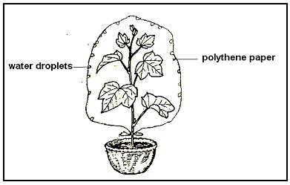

• Transpiration helps to cool the plants

• Transpiration gives room for the plant to absorb more water.

IMPORTANCE OF TRANSPIRATION TO THE ENVIROMENT It helps in rain formation

DANGERS OF TRANSPIRATION

• It leads to wilting

• It lowers crop yields

FACTORS THAT AFFECT THE RATE OF TRANSPIRATION

• Temperature:

When temperature is high transpiration is high and when it is low it lowers

• Humidity

When humidity is high transpiration I low and when it is low transpiration is high

• Size of the life

A small leaf loses less water than a big leaf

• Wind

When the speed of wind is high transpiration is high

• sunlight intensity

Bright light from the sun increases transpiration

HOW PLANTS CONTROL THE RATE OF TRANSPIRATION

• By shedding leaves

• By developing thorns

• By developing needle like leaves

• By folding their leaves

• By developing a layer of wax

PHOTOSYNTHESIS

• Photosynthesis is the process by which plants make starch.

• Photo means light

• Synthesis means to make

• The food made during photosynthesis is starch.

Conditions necessary for photosynthesis:

• Chlorophyll

• Sunlight.

Raw materials of photosynthesis

• Water

• Carbon dioxide

Requirements for photosynthesis

• Chlorophyll

• Sunlight

• Water

• Carbon dioxide

The products of photosynthesis.

• Starch - end product

• Oxygen - by product given off

Chlorophyll:

• This is the green colouring matter found in leaves.

• Its main function is to trap sunlight energy from the sun. Water

Combines with carbon dioxide to form starch. Carbon dioxide:

This gas passes through the small holes on a leaf called stomata. Carbon dioxide combines with water to form starch.

Sunlight

It splits water into hydrogen and oxygen

Importance of photosynthesis to plants.

Plants get food from photosynthesis. Importance of photosynthesis to animals.

• Animals get food from photosynthesis.

• Animals get oxygen from photosynthesis. Importance of photosynthesis to the environment. It reduces carbon dioxide in the atmosphere.

TYPES OF LEAVES.

• Simple leaves

• Compound leaves. Simple leaves

A simple leaf is a leaf with one leaf let on one leaf stalk

Examples of simple leaves:

• Simple serrated leaf

• Simple entire leaf

• Simple palmate leaf

• Simple lobbed leaf.

• simple digitate leaf.

• simple divided entire leaf. Structures of simple leaves

Simple entire leaf. Simple palmate leaf

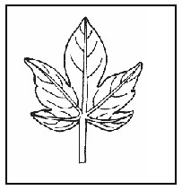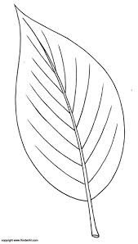

Simple serrated leaf. Simple Lobbed leaf.

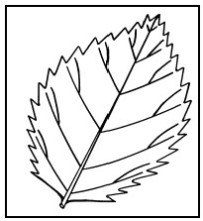

simple digitate

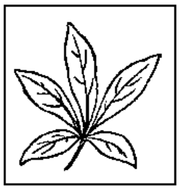

Simple divided

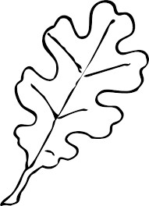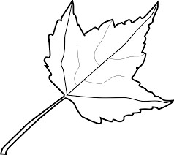

Compound leaves

A compound leaf is a leaf with many leaflets on one leaf stalk

Note:

The leaf blade is completely divided to form leaflets.

Examples of compound leaves:

• Compound trifoliate

• Compound pinnate

• Compound bipinnate

Structures of compound leaves

Compound trifoliate.

Compound Bipinnate.

Compound pinnate.

.

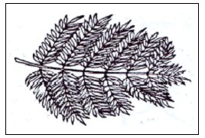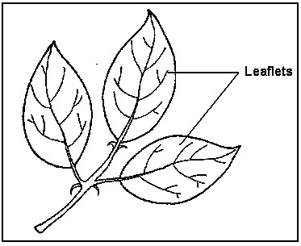

LEAF VENATION

Leaf venation is the a

rrangement of veins in a leaf.

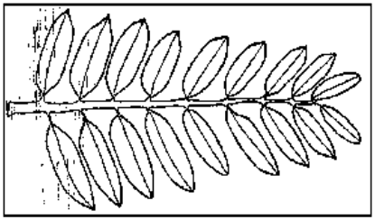

Types of leaf venation

• Network Venation

• Parallel Venation

The network venation

In network venation the veins make a net like structure

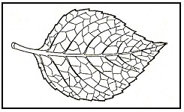

Examples of plants with network veins. o Beans

o Peas

o Hibiscus plant.

o Ground nuts

o Mango plant and many tree plants. The parallel venation

In parallel venation veins run from the stalk to the apex

Examples of plants with parallel veins

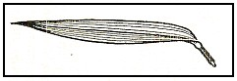

• Maize

• Sugar cane

• Millet

• Wheat

• Rice

• Elephant grass etc.

STEMS:

These are parts of a flowering plant with buds. Functions of a stem to plants

• It holds plants leaves and branches.

• It transports water and mineral salts from roots to the leaves.

• It transports food from leaves to other parts of the plant.

• Some plants store food in stems e.g. sugarcane, ginger, yams, Irish potato etc.

• Green stems make food for the plant.

1. Uses of stems to man

• Many stems are used as fuel.

• Some are used as herbal medicine.

• Some stems are used as food. e.g. Sugar canes, Ginger plant, Irish potatoes, etc.

• Some stems are a source of timber.

• Stems are used as poles.

• Some stems are sold to get money

Parts of a stem

o Terminal bud is the growing tip of a plant.

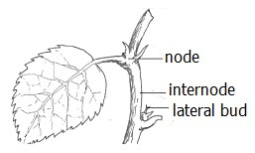

o The lateral bud can grow into a branch or flower. o A node is the part of a stem where a leaf is fixed.

o An internode is the distance (region) between two successive nodes.

Note: An axil is a space between each leaf and the stem. TYPES OF STEMS

o Upright stem/ erect stem o Underground stems

o Weak stems. Upright/erect stems

They are strong stems that are able to stand upright without any support

Examples of plants with Upright/erect stems:

o Trees e.g. Muvule etc. o Jack fruits

o Mangoes

o Maize etc.

Weak stems.

These are stems which cannot support themselves up right. Identify the two groups of weak stems

• Climbing stems

• Creeping stems

CLIMBING STEMS

They are weak stems that enable them to climb

Why do plants climb others?

o Plants climb others to get enough sunlight.

o For support

How weak stems climb others.

• By use of tendrils e.g. passion fruits, pea plant and some beans etc.

• By twining e.g. some yams, some beans. Morning glory money plant, guard, oilnuts, loofah pumpkins cucumber vanilla.

• By use of hooks & thorns e.g.bougain villea

Structures that help plants with weak stems to climb

• Tendrils

• Hooks or thorns

Illustration of climbing stems

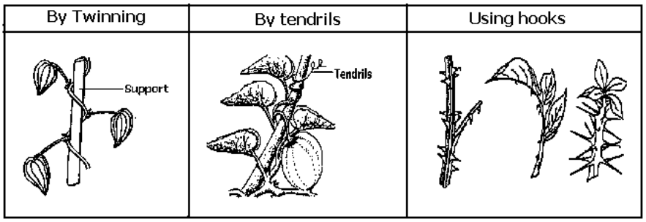

CREEPING STEMS.

These are stems that run along the ground. Examples of plants with creeping stems.

• Water melon

• Pumpkins

• Sweet potatoes

• Cucumber

• Straw berry

Illustration of creeping stems.

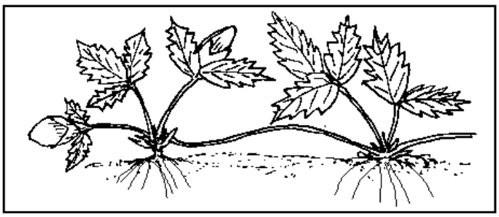

UNDER GROUND STEMS OR STORAGE STEMS.

These are stems that mainly grow underground. Types of underground stems

* Stem tubers
* o Bulbs

o Rhizomes o Corms

STEMTUBERS

o These are swollen underground stems with stored food. o We eat them as food.

Examples of stem tubers:

a) Irish potatoes.

Structures of stem tubers

Stem

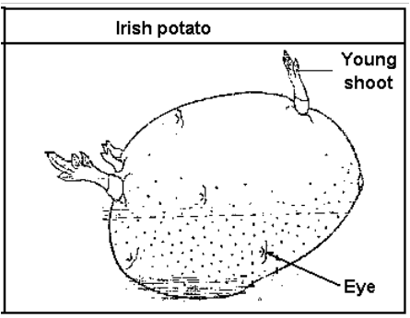

Scaly leaves

BULBS

o A bulb is an underground stem.

o Food in a bulb is stored in the fleshy leaves. o Bulbs have adventitious roots.

Examples of bulbs:

• Onions

• Garlic

• Leek

• Shallots

A bulb of an onion

Foliage leaves

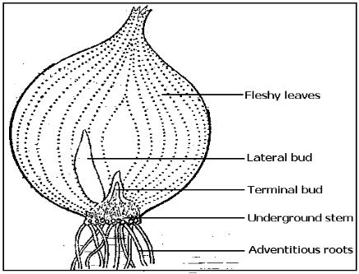

Scaly leaves

• Buds – Develop into a shoot system

• scaly leaves – protect the fleshy leaves

• foliage leaves – Transports water and mineral salts from the roots to the leaves.

• stem - holds the leaves

• storage leaves / fleshy leaves- sore the made food.

• Adventitious roots – Absorb water and mineral salts

RHIZOMES

o A rhizome is a horizontal underground stem. o Rhizomes develop adventitious roots.

o Rhizomes store food in the stem.

o An example of a rhizome is ginger,cannalily,turmeric

Structure of a rhizome

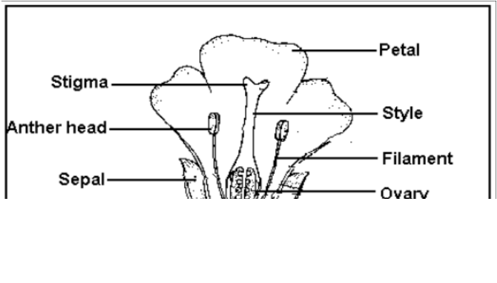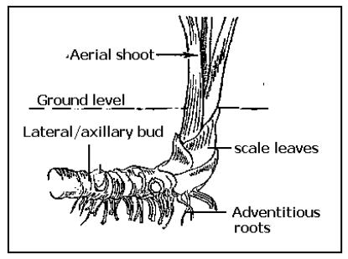

CORMS:

o A corm is a short vertical underground stem. o It is swollen with stored food

o It has scale leaves, lateral buds and adventitious roots. Examples of corms:

• Coco-yams

• Crocus

• gladiolus

STRUCTURE FOR COCO YAMS

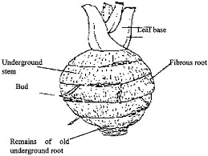

THE FLOWER

• A flower is a reproductive part of a plant.

• The main function of a flower is for reproduction

Parts of a flower

FUNCTIONS OF THE PARTS OF A FLOWER.

Sepals

Note

• They protect the flower when still in a bud stage.

• They make food for the plant.

A group of sepals is called calyx

Petals

• Petals attract pollinators

• They are coloured parts of a flower. Note

A group of petals is called corolla. Filament

• Holds the anther in position. Anthers

• Produce and store pollen grains.

Stigma

• Receives pollen grains. Style

• Holds the stigma in position.

• Joins the stigma to the ovary

• It passes pollen grains to the ovary.

Ovary

• Produces ovules

• Stores ovules

• It is where fertilization takes place in a flower

Flower stalk

• The stalk attaches the flower on the stem or branch

.

Receptacles

• It holds the ovary,nectaries,sepals,and petals.

• It produces nectar

THE PISTIL AND STAMEN The Pistil/carpel

This is the female part of a flower.

Parts that make up the pistil:

• Stigma

• Style

• Ovary

Structure of the Pistil

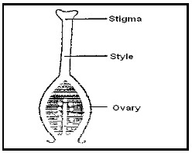

The Stamen

This is the male part of a flower.

Parts that make up the stamen:

• Anther

• Filament

The structure of the stamen

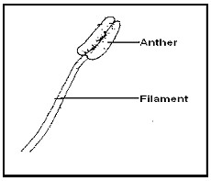

REPRODUCTIVE CELLS IN PLANTS

How do we call each of the following reproductive cells in plants?

• Female cells : Ovules

• Males cells : Pollen grains

POLLINATION

Pollination is the transfer of pollen grains from the anthers to the stigma of a flower on the plant.

Agents of pollination:

These are things responsible for the transfer of pollen grains to the stigma.

Agents of pollination o Wind

o Running water or flowing water o Animals

o Birds

o insects (wasps, bees, butterflies, moth)

Types of pollination

o Self-pollination

o Cross pollination

Self pollination

• Self-pollination is the transfer of pollen grains from the anthers to the stigma of the same flower.

• Flowers that under self-pollination have filaments taller than the style.

EXAMPLES OF PLANTS THAT UNDER GO SELF POLLINATION

• Beans

• Groundnuts

• Mangoes

• Oranges

• Cowpeas etc.

DIAGRAMSHOWING SELF POLLINATION

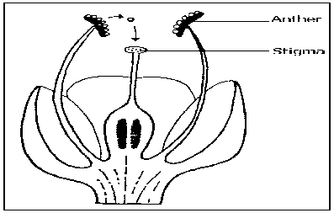

Cross-pollination

• Cross-pollination is the transfer of pollen grains from the anther of one flower to the stigma of another flower on different plants but of the same kind.

• Flowers that undergo cross pollination have filaments shorter than the styles.

EXAMPLES OF PLANTS THAT UNDER CROSS POLLINATION

• Maize

• Passion fruit

• Coco nut

• Pawpaw

DIADRAMSHOWING CROSS POLLINATION

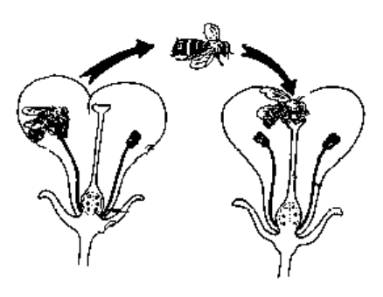

Characteristics of insect pollinated flowers.

• Have brightly coloured petals

• Have nectar

• Have good smell/ scent Produce few pollen

• Produce sticky pollen grains

Characteristics of wind pollinated flowers.

• Produce a lot of pollen grains

• Have dull petals

• Have no nectar

• No smell / scent

• The pollen grains are light

Importance of flowers to man

• Flowers are used for decoration on various functions.

• Some flowers are used in making of perfumes.

• Some flowers are used in the making of insecticides e.g. Pyrethrum.

• They are used to make dyes.

• Some flowers are a source of food.

• IT is given as gifts

• They are used to pay last respect to the dead

Importance of flowers to the plant

Flowers produce fruits and seeds that help in reproduction

Some flowers store food

FERTILIZATION

o Fertilization is the union of the female and male reproductive cells to form a zygote.

o Fertilization in plants takes place in the ovary.

o In flowering plants, the male gametes are the pollen grains and the female gametes are the ovules.

o After fertilization, the style dies and falls off

Note: After fertilization, the ovules develop into seeds and the ovary develops into a fruit.

Fertilization takes place in the OVARY

A FRUIT

A fruit is a fertilized ovary

Importance of fruits to a plant

• Protect seeds

• Help in scattering of seeds

IMPORTANCE OF FRUITS TO MAN

• They are sold to get money

• They eaten as food

SEEDS

• A seed is a fertilized mature Ovule.

• A seed develops into a new plant called seedling

Importance of seeds to man

• They are used for propagation.

• We eat seeds e.g. Beans, maize grain, groundnuts, etc.

• Some seeds are used to make decorations.

• They are used as herbal medicine.

Types/ Classes of seeds

• Dicotyledonous seeds (dicots)

• Monocotyledonous seeds (monocots) Dicotyledonous seeds

o These are seeds with two cotyledons. o Di means two.

Examples of Dicotyledonous seeds:

|  |  |  |  |
| --- | --- | --- | --- |
| 1. | Bean seeds |  | 2. Pea seeds |
| 3. | Ground nut seeds | 4. | Soya bean seeds |

|  |  |  |  |
| --- | --- | --- | --- |
| 5. | Coffee seeds | 6. | Mango seeds |
| 7. | Avocado seeds | 8. | Orange seeds |
| 9. | Pumpkin seeds | 10. | Water melon seeds |

11. Oil nuts 12 Simsim

External parts of a bean seed.

Internal parts of a bean seed

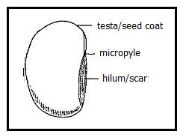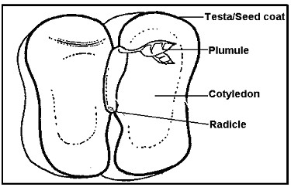

Functions of parts of a bean seed

Testa/ seed coat

• It protects the inner parts of a seed

Micro Pyle

• IT allows oxygen and air and water into a seed during germination. Cotyledon

• It stores food for the embryo in dicots.

Note: During germination, the cotyledon provides food to the embryo. Radicle

• It develops into a root system during germination

Plumule

• It grows into the shoot system during germination. EMBRYO

• It grows into a seedling

• It is made up of two parts: plumule and radicle

Monocotyledonous seeds

o These are seeds with one cotyledon. o Mono means one

Examples of monocotyledonous seeds:

• Maize

• Millet

• Sorghum

• Rice

• Wheat

• Barley

• Oats

• Rye

External parts of a maize grain

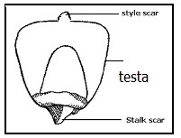

The internal parts of a maize grain

Functions of parts of a

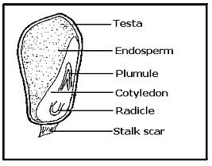

Testa/ seed coat

maize grain

• It protects the inner parts of a seed

Cotyledon

• Absorbs and supplies food fromthe endosperm to the embryo

Radicle

• It develops into a root system during germination

Plumule

• It grows into the shoot system during germination. Endosperm

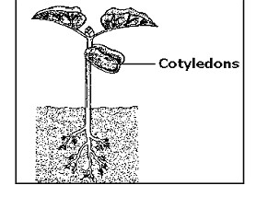

• It stores food for the embryo in monocots

Stalk scar

• It attaches the grain to a cob

Difference between monocots and dicots.

|  |  |
| --- | --- |
| Dicotyledonous | Monocotyledonous |
| 1. Have two cotyledons  Most Dicotyledonous seeds undergo epigeal germination  3. Stores food in the cotyledon.  4. Have tap root system  5. Have network veins | -Have one cotyledon  Most-Monocots undergo hypogeal germination  -Stores food in the endosperm.  -Have fibrous root system  -Have parallel veins |

GERMINATION

• Germination is the growing of a seed into a young plant.

• A young plant is called a seedling. Types of germination

o Epigeal germination

o Hypogeal germination.

Epigeal germination:

• Epigeal germination is a type of germination where the cotyledons come out of the soil.

An illustration of epigeal germination.

Examples of seeds that carry out epigeal germination.

• Beans seeds

• Soya bean seeds

• Groundnut seeds

• Coffee seeds

• Orange seeds

• Mango plants

• Pumpkin seeds

• Watermelon seeds

• Cow peas

Stages in epigeal germination

1. Hypogeal germination is a type of germination where the cotyledon remains underground.

Hypogeal germination

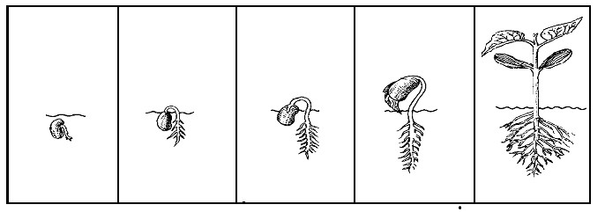

2. All monocotyledonous seeds carry out hypogeal germination.

An illustration of hypogeal germination.

Examples of ination.

seeds that carry out hypogeal germ

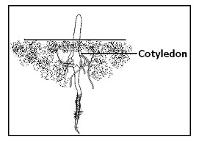

• Maize seeds

• Sorghumseeds

• Millet seeds

• Wheat seeds

• Rice seeds

• Oats seeds

• Mango

• Grampeas

• Kidney beans

Stages in hypogeal germination

C

onditions needed for a seed to germinate

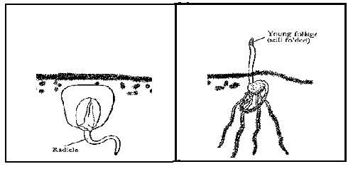

• Water or moisture

• Oxygen

• Warmth.

Importance of the conditions needed for germination

a. Water

• It softens the cotyledons.

• It dissolves food in the cotyledon for the embryo to use.

b. Oxygen

• Helps in respiration c. Warmth

• Provides optimum temperature for cell activity. QN :Which part of air is given off during germination

carbon dioxide

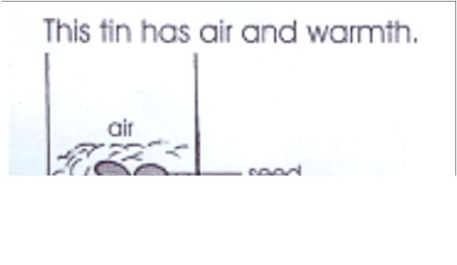

EXPERIMENTS ABOUT THE CONDITIONS NECESSARY FOR GERMINATION

a. Requirements

• Seeds

• Ice

• Cotton wool

• Test tubes

• Boiled water

STEPS

Get four test tubes and mark on them1-4

Test tube i

Place a piece of dry cotton wool at the bottom and put in some seeds

Put the test tube in a warm place so that seeds can get enough wormth,air but no water

Test tube ii

• Place wet cotton wool at the bottom and some seeds

• Add cool boiled water. then pour a layer of oil on top

Test tube iii

• Put wet cotton wool in the test tube and put in seeds

• Place the test tube in a warm place for seeds to get water, air and warmth

Test tube iv

• Put wet cotton wool with some seeds in test tubes

• Put ice blocks in the test tube

An illustration on conditions needed for germination to take place a) Testing for water whether it is necessary for germination.

The experiment above has oxygen, warmth without water. So the seeds will not

germinate.

31

b) Testing for oxygen whether it is necessary for germination.

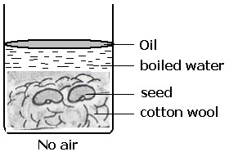

The experiment above has water, warmth without air. So the seeds will not germinate. c) Testing for warmth whether it is necessary for germination.

The expe ygen without warmth. So the seeds will not germinate.

riment above has water, ox

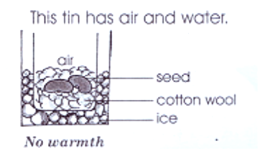

d) Testing on germination.

The experiment above has water, oxygen and warmth. So the seeds will germinate. OBSERVATION

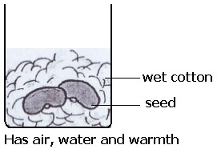

• After 3 days the seeds in test tubes 3 germinated

• The seeds in the other test tubes did not germinate

CONCLUSIION

• In test tube 3 all the condition were present .

• So, for a seed to germinate, all the conditions must be present.

Seed viability

This is the ability of seeds to germinate when all the necessary conditions are present

VIABLE SEEDS

Viable seeds are seeds that can germinate when necessary conditions are present. Qualities of viable seeds

Seeds should be mature and dry

Seeds should be not have holes

Should not be broken

Should not be rotten

Should be of good quality

What is seed dormancy?

Seed dormancy is a condition when the seed does not have the necessary conditions to germinate,

FACTORS THAT LEAD TO SEED DORMANCY

Broken seeds

Damaged seeds

Un healthy seeds

Premature seeds

Holes in seeds

END OF TOPIC REVISION EXERCISE.

1. Give one example of a dicotyledonous seed.

2. What name is given to the following?

a. Male part of a flower.

b. Female part of a flower.

3. How is chlorophyll important during photosynthesis?

4. Why does a seed planted in soil which is covered in ice fail to germinate?

5. How are leaves of a bean plant different from those of a maize plant?

6. State any one way plants depend on animals.

7. Mention one plant that develops a fibrous root system.

8. What are flowering plants?

9. State one way plants benefit from other plants.

10. What is photosynthesis?

11. Mention two things plants need to carry out photosynthesis.

12. What name is given to the main product of photosynthesis?

The diagram below shows a part of a plant. Use it to answer questions that follow.

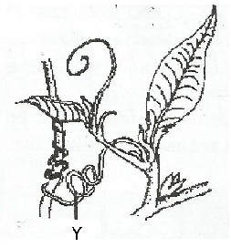

a. What type of stems is shown in the diagram above?

b. How is part marked Y useful to the stem?

c. Why do plants with weak stems climb others?

d. Apart from climbing stems, name any other type of stems possessed by plants.

2. Mention the importance of water to a germinating seed.

3. How is burning similar to germination?

4. Name the pollinating agent that pollinates flowers at night.

The diagram shows an underground stem. Use it to answer the questions that follow

a. Name the plant shown above.

b. State the function of part marked X. c. Name roots marked K.

d. Where does the plant above store excess food?

GROWING CROPS AND FOOD PRODUCTION GROWING CROPS

Crops are plants grown by man for a purpose

WHY FARMERS GROW CROPS.

• For food

• For income

• For feeding animals

• T0 get raw materials for industries

Types of crops commonly grown o Fruit crops

o Cereals/grain crops, o Vegetable crops,

o Legume crops o Root crops.

Fruit crops

What are fruit crops?

Fruit crops are crops that bear fruits.

Examples of fruit crops o Apple crops

o Orange crops

o Mangoes crops

o Pineapples crops o Paw paw crops

Cereals

Cereals are plants that bear grains. Examples:

o Rice crops

o Wheat crops o Maize crops o Oat crops

o Sorghum crops o Millet crops Vegetable crops

They are crops that are eaten as sauce

EXAMPLES OF VEGETABLE CROPS

o Cabbage crops

o Cucumber crops o Spinach crops

o Lettuce crops

Root crops

These are crops with swollen roots that are eaten. Examples of root crops

o Cassava crops

o Sweet potato crops o Carrot crops

o Beet roots o Root turnip

Legume crops

These are crops that have root nodules. Examples:

o Bean crops o Pea crops

o Ground nuts crops o Soya bean crops

o Simsim

o Cow peas

Characteristics of legumes

• They have root nodules

• They have pods

Diagram showing root nodules.

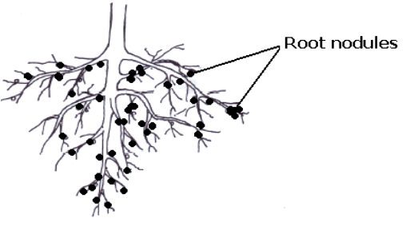

Note:

1. Root nodules keep nitrogen fixing bacteria.

2. Nitrogen fixing bacteria fix nitrogen in the soil.

3. Nitrogen improves soil fertility. The structure of a pod

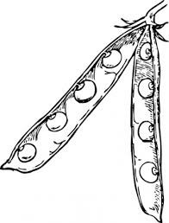

GROUPS OF CROPS

Crops are grouped according to the time they take to mature,

There are mainly two groups of crops :

• Annual crops

• Perennial crops

Annual crops

o These are crops which mature within a year. o We harvest them only once.

Characteristics of Annual crops

• They mature within a year

• Produce yields once in their life time

Examples of Annual crops:

o Maize o Rice

o Beans

o Ground nuts o Cabbage

o tomatoes

o sorghum etc. Perennial crops

o These are crops that take more than a year to mature. o They give yields yearly

Examples Perennial crops :

o Coffee, o Tea,

o Banana,

o Oranges,

o Sugar cane,

o Mangoes o Apple

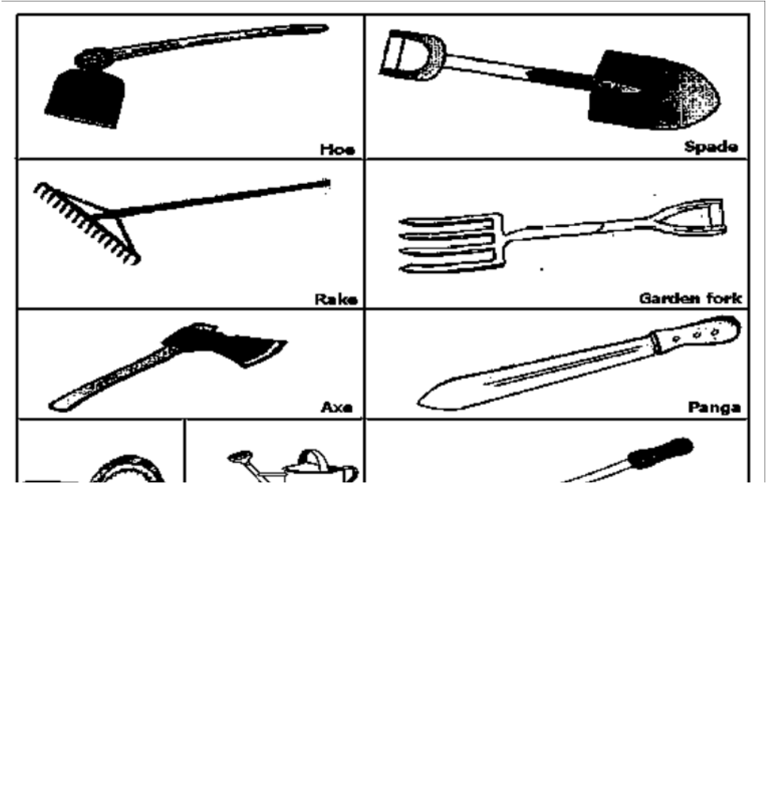

o Jackfruit o Avocado

o Straw berries etc.

Why do farmers prefer growing annual crops to perennial crops? Annual crops mature faster than perennial crops.

GARDEN TOOLS, EQUIPMENT AND MATERIALS

These are simple machines farmers use to carry out some activities in the garden

Examples of garden tools and their functions

1. Hoe -used for digging, weeding and harvesting root crops, planting crops

2. Panga - used for cutting small trees, harvesting some crops, pruning trees, clearing weeds

3. Rake -used for collecting dug out weeds, spreading manure and levelling soil

4. Watering can - used for watering crops.

4. Slasher - used for slashing weeds

5. Trowel - used for digging out seedlings during transplanting.

6. Wheelbarrow - used for transporting manure, tools, harvested crops, transporting seedlings.

7. Axe-used for cutting big trees

8. Secateurs - used for pruning.

9. Garden fork - used for turning manure. Or lifting manure

10. Forked hoe - used for harvesting rhizomes, dig out deep rooted weeds, digging hard grounds for hollowing

11. Sickle - used for harvesting wheat and rice, cutting grass

12. Pick axe - used for digging hard grounds and stony area

13-Knap sack sprayer – for spraying pesticides and herbicides

Diagrams of garden tools

38

Caring for garden tool

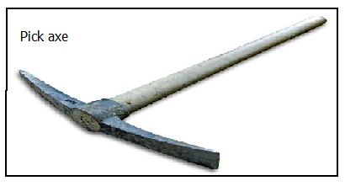

Caring for garden tools.

o Garden tools must be kept in cool a dry place. o Cleaning them after use

o Sharpen cutting tools regularly. o Replacing spoilt parts

o oiling/greasing moving parts to prevent rusting o Painting those that need to be painted

o Using garden tools for the right purpose

Ways of preventing garden tools from rusting

• Painting garden tools

• Oiling garden tools

• Keep garden tools in cool dry places

Effects of rusting on garden tools

• garden tools become blunt

• Garden tools become weak

• Tools develop holes

FOOD PATH

Food path are different stages of food production

The types of food path

• Village food path

• Town food path

• Earning food path

a) Village food path

The type of food path where the food is grown for home consumption. Stages in village food path

• Land preparation

• Selecting planting materials/ seeds

• Planting

• Caring for crops

• Harvesting

• Storing

• Preparation of food

• Eating

b) Town food path

The type of food path where people in town get food

Stages involved in a town food path

• Harvesting

• Storing

• Transportation of food to the market.

• Selling the food.

• Preparation of food

• Eating

c) Earning food path

The type of food path where food is obtained after earning salary

• Stages in earning food path

• Earning salary

• Budgeting

• Buying food

• Preparing food

• Eating.

Blocks in food path

• These are factors that affect the production of food. Examples of blocks in a food path

• Pests

• Diseases

• Drought

• Civil wars

• Infertile soil

• Bad roads

• Floods

• Storms

• Hailstones

• Poverty

• Land slides

CROP GROWING PRACTICES

o Land clearing

o Digging/ ploughing

o Selecting planting materials o Planting/ sowing

o Caring for crops e.g. weeding, mulching, pruning, thinning etc

Land preparation

it is the way of making land ready for planting

o it’s done to remove the bush, trees and grass on the soil. o it’s better to clear land in the dry season.

Steps in land preparation

• Clearing land which involves cutting grass and trees removing tree stumps o Clearing the land is done during the dry season

Digging/ Ploughing

• This is done to make the soil loose, soft and also to burry weeds.

• To allow water and air to enter the soil.

• It is done using hoes, tractors, ox ploughs and forked hoes. Harrowing the land

o This is the breaking of big lumps of soil which are left after Ploughing. o It makes the soil loose.

o Also it kills weeds which could have started germinating after Ploughing.

o It is done using a tractor with disc harrows, ox plough, forked hoe and hand hoe. Selection of planting materials

Planting materials are the different parts of a plant used for plant multiplication. Examples of planting materials

o Seeds

o Stem cuttings

o Vines

o Suckers o Bulbs

o Stem tubers

Factors to consider when selecting planting materials

• Materials should be free from diseases and pests.

• Should not be damaged. broken

• Seeds should be mature and well dried.

• Stem cuttings should bear lateral buds.

• Seeds should not be rotten

PLANTING SEEDS

1. Some seeds are planted directly into a well-prepared garden. Examples

• Maize

• Beans

• Peas

• Cotton

• Groundnuts etc.

1. Others are first planted in a nursery bed.

Examples of seeds first planted in a nursery bed

• Tomatoes

• Onions etc.

• Cabbage,

• Egg plants

• Lettuce, spinach etc.

A nursery bed

A nursery bed is a small garden prepared for raising seedling

Diagram of a nursery bed.

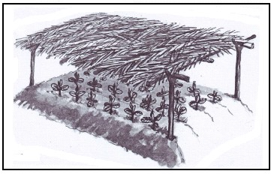

Note: Seeds of these crops cannot grow through heavy soils. Site for a nursery bed

o Should be in a place protected from direct wind. o A place with good drainage.

o A place near a water source.

o A place far from bushes/forest o A place protected from animals. Activities carried out on a nursery bed

• Watering

• Spraying with chemicals

• Weeding

• Hardening off

• Thinning

Note:

Hardening off is a way of making seedlings get used to conditions they are to meet in the garden.

Importance of a nursery bed

a) It protects the seedlings from harsh weather conditions e.g. i. Direct sunlight

ii. Direct rain drops iii. Strong wind

b) It helps in proper selection of good seedlings.

c) It gives farmers time to prepare the main garden. d) It helps in providing easy care to the seedlings Transplanting

• Is the transfer of seedlings from the nursery bed to a well prepared main garden

• It is done in the evening to avoid excess loss of water through transpiration

• To avoid wilting

Why is a trowel used for transplanting?

• It scoops seedlings without damaging the roots

Time/Season of planting

• Planting should be done during the wet season.

• It is good to plant early during the first rains because: Importance of early planting

o Crops make proper use of rainfall for that season.

o Crops grow fast enough and compete well with weeds. o Helps to control pests and diseases.

o Crops mature fast and get good market. Methods of planting seeds.

o Row planting

o Broad casting

Row planting

This is the planting of seeds/ seedlings in a line. Examples of seeds planted using row planting:

o Beans o Maize

o Ground nuts o Cotton

o Soya beans o Coffee

o Tea

Advantages of row planting

• Few seeds are used.

• It is easy to weed the crops.

• Spacing in lines helps to control pests.

• It is easy to spray the crops.

• It is easy to harvest the crops. Disadvantages of row planting

• Takes a lot of time/tiresome.

• It is tiresome/tiring

Broadcasting

This is when seeds are thrown randomly. Examples of seeds planted using broadcasting:

o Millet

o Sorghum

• Sim-sim

• Rice

• Beans

• Maize

Advantages of broadcasting

• Time saving.

• Requires less labor force

Disadvantages of broadcasting

• It wastes seeds.

• It is difficult to weed,

• it is difficult to spray

• It is difficult to harvest

• It can lead to overcrowding of seedling

Gap Filling

1. This is the replacement seeds or seedlings in spaces where they didn’t germinate.

2. It is done not to waste land. Thinning

Thinning is the removal of excess or poorly growing seedlings from the garden

Examples of crops that need thinning

• Maize,

• Cotton,

• Rice,

• Millet,

• Sorghum, etc.

Methods of thinning:

o Uprooting/

o Cutting the plant at the base area. o Digging out the plant

Importance of thinning

o Thinning controls pests .HOW by reducing hiding places for pests.

o It reduces competition for sunlight, minerals and water among crops. o Thinned materials can be used for mulching.

o It improves crop yields

o Thinned materials can be used for gap filling. Pruning

Pruning is the removal of excess branches or leaves from a plant

Garden tools used for pruning o Secateurs

o Pruning saw o Shears

Importance of pruning

o It controls crop pests.

o Reduce weight on the plant.

o Reduce competition for sunlight, o It improves on crop yields

o It makes harvesting easy

o Pruning gives good space for harvesting. Mulching

1. Mulching is the covering of soil with dry plant materials. Plant materials that can be used:

• Dry maize stalks

• Dry leaves

• Coffee husks

• Wood shaving

• banana fibres

• Dry grass

Advantages of mulching

• It maintains soil moisture

• Mulching controls soil erosion.

• Mulching improves soil fertility

• Mulching controls the growth of weeds. Disadvantage of mulching

• Mulches hide pests.

• Mulches can easily catch fire and destroy crops.

Manuring

• It is tiring to mulch a large garden

• Act of adding manure to soil.

• Manures is natural fertilizers.

• Manure is got from dead plants, animals and animals dung.

• Manure helps to improve soil fertility. Types of manure:

• Compost manure made from kitchen refuse and plant remains

• Farmyard manure made from animals dung and urine and animal waste

• Green manure made from green plants when ploughed into soil

• Organic mulches made from rotting of mulches

Watering

• Act of providing water to crops when there is little water in the soil.

• It is done to prevent crops from drying and dying.

• Watering can also be done to newly transplanted seedlings.

• It is done using a watering can.

• It is done late in the evening. Or early in the morning weeding

Weeding is the removal of unwanted plants from the garden.

Weeds are plants growing where they are not wanted

Examples of common weeds:

• Wandering Jew

• Spear grass

• Black jack

• Star grass

• Wild finger millet

• Couch grass

• Elephant grass

• Pig weed

Importance of weeds

• Weeds are source of food for both people

• Legume weeds improve on the soil fertility by adding nitrogen.

Controlling soil erosion

Weeds are used for feeding animals

Dry weeds can be used as mulches

Dangers of weeds

• Weeds hide pests .

• Weeds compete with crops for sunlight, soil nutrients and water with crops.

• Weeds make harvesting difficult

• Weeds contaminate yields weeds lower the quantity of harvests

• Weeds make pruning difficult

• They costly to manage

• Some are poisonous to animals. Importance of weeding

• Weeding controls crop pests

• It makes harvesting easy

• It makes spraying easy

• It makes pruning easy

• It reduces completion for sunlight, soil nutrients and water between crops and weeds

Ways of controlling weeds

• Spraying with herbicides.

• Mulching.

• Uprooting.

• Slashing (slashing is normally carried out in crops with wide spacing e.g. Coffee and banana plantation)

• Digging them out

CROP PESTS

They are organisms that destroy crops

COMMON CROP PESTS

|  |  |  |  |  |
| --- | --- | --- | --- | --- |
|  | Crops | Pests | | Affected part |
| 1 | Cassava | Monkeys  baboons  Mole rats | | Roots |
| 2. | Sweet potato | a | Sweet potato weevil | tuber |
| b | Squirrel | Roots |

|  |  |  |  |  |
| --- | --- | --- | --- | --- |
|  | C | | Eel worms | Roots |
|  | d | | Mole rats |
|  |  | | Monkeys |
|  |  | | baboons |
| 3. | Irish potato | Irish aphid | | Leaves |
| 4. | Carrots | Eel worms | | Roots |
| 5. | Sugar cane | a. Stalk borers | | Stems |
| b. Aphids | | Stems |
| 6. | Banana |  | Fruits | |
|  | Stem(corm) | |
| 9 | Cabbage |  | Stem | |
| 10 | Coffee | locusts | | Leaves |
| 11. | Maize | Maize stalk borer  Weaver birds  Termites Rats weevils | | Stems  Grains |
|

COMMON DISEASES OF CROPS

|  |  |  |  |  |
| --- | --- | --- | --- | --- |
| Crop | | Diseases | | Affected part |
| 1 | Cassava | a | Cassava mosaic | Leaves |
| b | Brown streak | Leaves and tubers |
| 2 | Sweet potato | Sweet potato blight | | Leaves and stem |
| 3 | Coffee | a | Coffee berry | Coffee beans |
| disease |
| b | Wilt disease | Leaves |
| Banana | | a | Panama disease | Leaves and stem |
| b | Wilt disease | Leaves |
|  |  |  | leaves | |
| 6 | Sugar cane | Ratoon stunting | | Stem |
| disease | |
| 7 | Ground nuts | Rosette disease | | Leaves |
| 8 | Maize | Maize streak | | Leaves |
| rust | |

signs of pest damage to plants

• Holes in leaves, seeds, and roots

• Spots on leaves

• Deformed part.

• Rotten plant parts

Signs of disease damage to plants

• Deformed parts

• Premature ripening of fruits

• Stunted growth

Methods of controlling pests

• Uprooting

• Proper spacing

• Early planting

Methods of controlling crop diseases

• Uprooting infected crops

• Proper spacing

• Early planting

• Spraying with pesticides

• Using scare crows

• Setting trap

• Crop rotation

• Planting good se

• Rearing cats

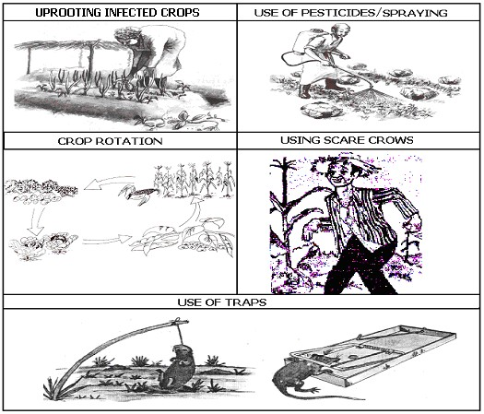

Harvesting of crops

• Harvesting is the collecting or removal of ready crops froma garden.

• Harvesting should be done when the crops are ready.

• Most crops that need drying should be harvested in dry season. NOTE:

Harvesting is done during the dry season because there is enough sunshine to dry the harvested crops.

Methods of harvesting crops

A. Cutting

Examples of crops harvested by cutting:

• Banana

• Sugar cane

• Millet

• Sorghum

• Wheat

• Rice

• Maize

B. Picking/Plucking

Examples of crops harvested by picking

• Coffee

• Tomato

• Egg plants

• Cocoa

C. Uprooting using hands

Examples of crops harvested by uprooting using hands

• Ground nuts

• Onions

• Carrots

• Cassava

D. Digging out the crop

Examples of crops harvested by digging out the crop

• Cassava

• Sweat potato

• Yams

• Coco yam

• Irish potato, etc.

Storing harvested crops

1. Harvested crops are commonly stored in granaries, stores, silos, maize cribs, etc.

• Crops that can rot easily can be stored in special made structures with coolers.

• Crops that do not rot easily can be stored in granaries, silos, maize cribs and stores.

Granaries

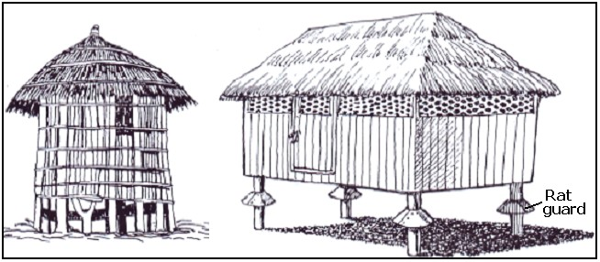

Conditions for proper storage

• Harvested crops should be stored when they are dry.

• The roofs of stores should not leak.

• Stores should have good ventilation.

• Rat guards should be fixed on the granary.

• The seeds should be dusted with pesticides to protect them from pests .

Importance of storing harvested crops.

• It prevents wastage.

• Helps to get what to eat in the dry season.

• Helps farmers to sell their produce when there is good

• It helps farmers to keep what to plant in the next season. Food preparation

What is food preparation?

Food preparation is the making of food ready for eating. Give any four ways of preparing food

• By roasting

• By baking

• By boiling

• By frying

• By deep frying

• Steaming

Why do people prepare food?

• To make food soft

• To kill germs and worms

• To make food tasty

FARMRECORDS

Farm records are written information about activities carried out on the farm

Examples of Records kept by crop farmers:

• Sales records,

• Production records

• Health records

• Expenditure records

Uses of farm records

• Records help the farmer to know his profits or losses.

• helps to make decisions

• Records help the farmer to plan for the farm

• for proper taxation of the farm

• Records help the farmers to get loans.

• It helps to know his income and expenditure

END OF TOPIC REVISION EXERCISE.

1. To what group of crops does a sweet potato belong?

2. State one way root nodules are important to soil.

3. State one danger of leaving garden tools exposed to water and oxygen.

4. Mention one importance of mulching crop gardens.

5. What is a pest?

6. Give one example of a pest in a garden.

7. How are pests dangerous to a crop garden?

8. Give the importance of each of the following garden tools to a farmer:

a. Wheelbarrow b. Hoe

c. Garden trowel

9.How are the following practices important in crop growing?

d. Pruning e. Weeding f. Thinning

11. Use the diagram below and answer questions that follow.

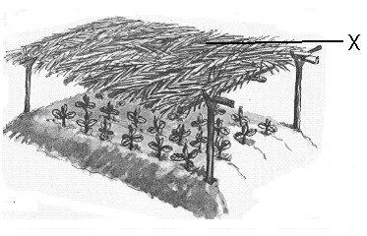

a. Name part marked X on the diagram.

b. Name the structure shown in the diagram. c. How is the structure useful to a farmer?

d. How useful is part marked X in the structure above?

e. Identify any one activity carried out in the structure above.

12. Give one example of manure.

13. Mention one way a P.4 child can identify a leguminous crop.

14. Why is harvesting of cereals done in dry seasons?

15. Name one crop propagated by stem cuttings.

16. Give one method of planting seeds.

CHANGES IN WEATHER AND CLIMATE IN THE ENVIRONMENT Weather

Weather is the condition of the atmosphere of a place at a given/ particular time.

Types of weather

|  |  |  |
| --- | --- | --- |
| • | Rainy weather |  |
| • | Windy weather |
| • | Sunny weather |
| • | Cloudy weather | etc |

A WEATHER CHART

o Cloud cover o Sunshine

Elements of weather o Rain

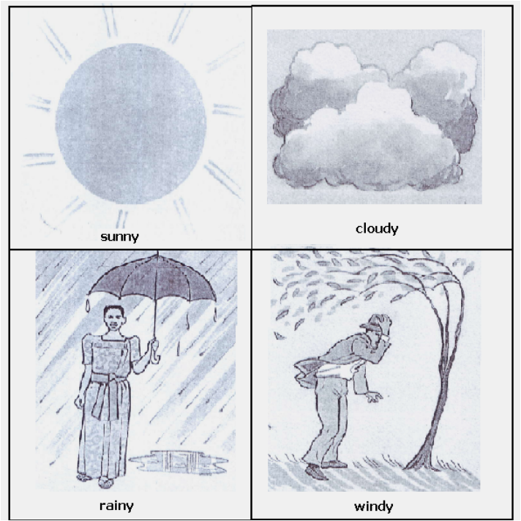

o Temperature o Humidity

o Air pressure/ Atmospheric pressure

CLOUDS

• Clouds are condensed masses of water vapour floating in air.

• Clouds are formed when the rising water vapour condenses in the atmosphere.

• Clouds are grouped according to their heights and general shape.

Types of clouds

• Cirrus clouds.

• Stratus clouds.

• Nimbus clouds.

• Cumulus-nimbus clouds

Nimbus clouds

• These are clouds that bring or give us rain.

• They don’t have any special shape.

• They are the nearest clouds to the earth.

Stratus clouds

• They spread in the sky widely in calm flat layers.

• They show a sign of bad weather. Cumulus clouds

• They are white clouds, which resemble cotton piles

• They can develop into thunder clouds and thus they indicate rain. Cirrus clouds

o They look like feathers in the sky. o They are the furthest in the sky.

o Cirrus clouds appear in dry weather and often indicate storm. Cumulus nimbus

• They are observed during storms

• They cause thunder storms

• They are close to the ground

• They contain a lot of moisture

Advantages of clouds

o Clouds protect us from direct sunshine. o Clouds give us rain

Dangers of clouds

• Cause lightning

• Bring heavy rainfall

• Cause accidents to people who use air transport

How are clouds formed? By condensation process

WATER CYCLE.

• A water cycle is a process by which rain is formed.

• Heat from the sun causes evaporation of water in the water body and transpiration in plants

• The vapour condenses to form clouds

• The clouds give us rain

A diagram to illustrate a water cycle

Components n

ts of the environment that help in rain formatio

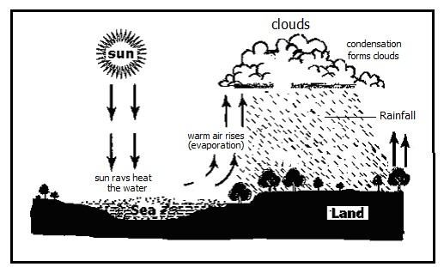

• Sun

• Plants

• Water bodies

An experiment to show the water cycle

Make a charcoal stove and make sure that it produces or gives enough heat.

Put water in a kettle and cover the top outlet leaving only the spout open.

Put the kettle full of water on a charcoal stove and leave it to boil.

When water boils, it will give out steam. (Water vapour) through the spout. e. Get a pan full of cold water and put it near the spout where water vapour comes

From

E

xplantation

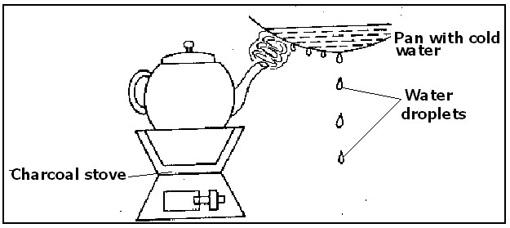

• A charcoal stove represents the sun.

• Kettle of boiling water represents the water bodies.

• Steam from boiled water in the kettle represents water vapour from water bodies after

• The sun has heated the water.

• A pan full of cold water represents condensation point.

• Condensed vapour on the surface of a cold pan represent clouds.

• Water droplets represent rain. Rain

Is water drops falling from clouds

Rain drops

Its the total amount of rain received in an area

Importance of rain

• Rain gives us water for cooking, bathing etc.

• Rain-removes dust in space and we breathe in cool air.

• Rain softens the soil.

• Rain adds water to water bodies.

• Rain supports plant growth

Disadvantage of rain

o Too much rain brings floods which destroy property and lives. o During rain, lightning can kill people and animals.

o Too much rain leads soil erosion.

A RAIN GAUGE

• A rain gauge is an instrument used to measure rainfall received in an area.

• It is put in an open space to collect the right amount of rain received.

• Rainfall is measured in millimeters.

Why is rainfall measured in millimeters?

To measure the depth rain has entered the soil.

A diagram of a rain gauge

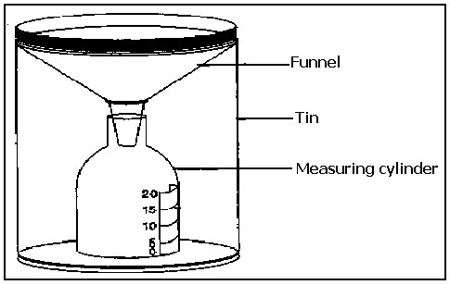

Sources of water

Natural sources of water o Rain (main source)

o Lakes

o Oceans o Seas

o Streams o Rivers

o Springs

Artificial sources

• Boreholes

• Wells

• Valley dams

• Ponds

Uses of water in the environment

• People use water for bathing, washing plates and clothes etc.

• Water animals get their food and oxygen from water.

• Flowing water helps to produce hydro- electricity.

• Water is used for watering crops.

• Animals drink water, etc.

Ways water sources get contaminated

• Disposing faeces /rubbish

• Swimming in water sources

• Spitting in water sources

• Washing in water sources

• Urinating in water sources

• Fetching water using dirty containers

Containers for harvesting water

• Saucepan

• Drums

• Basins

• Buckets

• Jerry cans

• Pots

Maintenance for water sources

• Fencing

• Repairing damaged parts

• Putting strict laws

• Planting grass around

WEATHER INSTRUMENTS

o Weather instruments are found at a weather station.

o At a weather station, delicate instruments are kept in a white box called a

Stevenson screen.

o These instruments include the barometer, hygrometer and maximum and minimum

Thermometer.

o The sunshine recorder, wind vane, wind sock, rain gauge and anemometer are placed in the open space of the weather station.

Weather instruments and their uses

1. Thermometer - Measures temperature.

2. Sunshine Recorder - Records hours it has shined in a day.

3. Wind vane - Shows the direction of wind.

4. Windsock - measure the strength of wind.

5. Anemometer - Measures the speed of wind

6. Hygrometer - Measures humidity.

7. Barometer - Measures atmospheric pressure.

8. Rain gauge - Measures rainfall received in an area.

TEMPERATURE

o Temperature is the degree of hotness or coldness of a body or place. o The instrument used to measure temperature is called thermometer.

o A thermometer is read in two scales namely:

o Fahrenheit.

o Centigrade or Celsius.

o Temperature is measured in degrees centigrade or degrees Fahrenheit. What are the basic units for measuring temperature?

Types of thermometers

1. Clinical thermometer.

2. Minimum and maximum thermometer.

3. Scientific thermometer

4. Wall thermometer

Minimum and maximum/Six’s thermometer

• This is sometimes called the six’s thermometer because it was first made by James six.

• The minimum and maximum thermometer is used to measure the lowest and highest temperature of the day.

• It uses both alcohol and mercury. The minimum and maximum thermometer

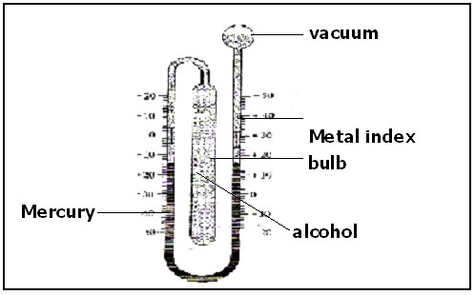

To read the temperature looks at the lower ends of each index. Clinical thermometer:

1.How is a clinical thermometer important to a doctor? It is used for measuring human body temperature

2.What is the normal body temperature for a human being?

370 C.

3.State any two body parts where a clinical thermometer is put when taking up the readings.

Under the tongue, under the armpit, in the anus, in the vagina

4.Why is the bulb of the thermometer put under the tongue when taking up the readings? Under the tongue has constant body temperature.

5.Give any two groups of people who commonly use clinical thermometer

Doctors, Nurses, midwives and first aiders

6.Why does the doctor shake the thermometer before using it on another person?

• To reset the thermometer

• To force the mercury to go back to the bulb

• To get correct measurements

7.Draw the clinical thermometer and name its parts.

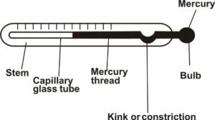

Functions of parts of a clinical thermometer

Kink: To prevent the back-flow of mercury when taking up readings

Why is the stem made up of a glass? The glass is transparent

Why is mercury commonly used in thermometers?

• Mercury is a good conductor of heat.

• Mercury does not stick on the bore.

• Mercury expands uniformly. SUNSHINE

•When the sun is in the sky around mid-day the condition is not the same as it is in the morning or evening.

•Sunny weather is highly determined by the brightness or less brightness or non- existence of sunshine.

•The length of time it has shone on a particular day in a particular place is measured by an instrument called sunshine recorder.

Note: the sun rises in the East and sets in the West

A sunshine recorder

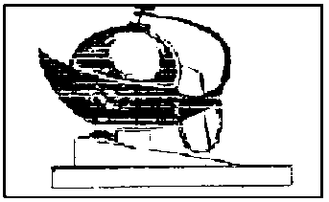

Advantages of sunshine

• Sunlight helps our crops to make their own food.

• Sun heat dries our harvested crops.

• Sun heat helps in the formation of rainfall.

• Sunlight helps our skins to make vitamin D.

• Sunshine helps to kill some germs. Disadvantages of sunshine/ sun

• Prolonged sunshine makes the day very hot.

• Prolonged sunshine dries crops.

• Prolonged sunshine dries same water sources.

• It causes draught

Effects of the changes in the environment.

• Too much rain causes floods.

• Drought leads to very high temperature in the atmosphere.

• Drought leads to weathering of vegetation leading to lack of food and water for animals.

• Strong wind destroys plants and buildings.

• Too much rainfall leads to soil erosion, etc.

Wind

Wind is moving air or wind is air in motion

Instruments that describes wind and their diagrams

A. Wind vane

It shows direction of wind

Diagram of wind vane



B. Windsock

It measures the strength of wind

Diagram of windsock

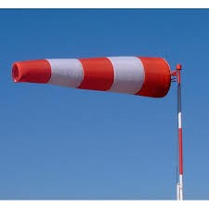

C. Anemometer

It measures the speed of wind

Diagramof Anemometer

• Humidity is the amount of water vapour in the atmosphere at a given time

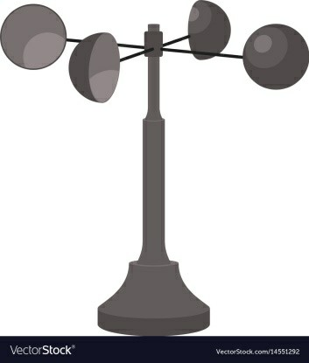

• Hygrometer is an instrument used to measure humidity.

• Barometer is an instrument used to measure air pressure

END OF TOPIC REVISION EXERCISE.

• What is weather?

• Name any one process involved in the water cycle.

• Name the instrument used to measure humidity in the atmosphere.

• How are nimbus clouds important in the environment?

The diagram shows natural changes. Use it to answer the questions that follow.

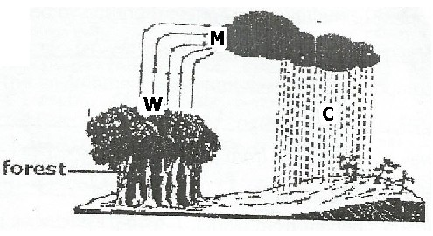

i. What process in nature is shown in the diagram?

ii. Name the process marked W.

iii. Mention the process that takes place at M. iv. How is C important to plants?

2. Identify any two types of weather.

3. Name the type of clouds that spread in the sky widely in calm flat layers.

8. Why is a rain gauge placed in an open space?

9. Identify any one artificial source of water.

10. Give one use of water in a home.

11. Name any one instrument kept in a Stevenson screen.

12. What is temperature?

13. The diagram below shows one of the instruments used in the community. Use it to answer questions that follow:

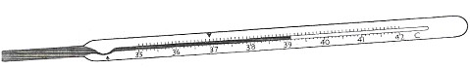

a. Name the instrument shown in the diagram. b. How is the instrument useful to people?

c. State two advantages of sunshine.

PERSONAL HYGIENE

• Personal hygiene is the general cleanliness of the body

• It is the keeping of the body clean.

Parts of the body that needs proper cleaning:

• Fingers/Finger nails

• Hair

• Face

• Teeth

• Armpits

• Sexual organs

• Between the buttocks

Ways of keeping clean

• Bathing using safe water and soap.

• Cutting finger nails short.

• Washing the face after sleep.

• Washing the hands whenever they are dirty.

• Shaving hair.

• Combing hair using clean combs.

• Washing clothing and beddings.

• Brushing teeth regularly.

• Brushing shoes

Reasons why we wash our hands

• To remove germs

• To wash away germs

• To prevent diarrhoea or faecal diseases

Things used for keeping our bodies clean

• Bathing sponge

• Safe water

• Towel

• Soap

• Shavers

• Combs

• Tooth brush and tooth paste

• Razor blades

• Nail cutters

• Dental floss

Importance of keeping our bodies clean

• To prevent bad smell on the body.

• To prevent diseases.

• To be healthy.

• To remove sweat

• To kill germs

• To kill parasites.

Keeping beddings and clothing clean

• Washing them using water and soap/detergents.

• Ironing them when washed.

• Spraying disinfectants on them.

• Keeping them in clean safe places if not in use.

Why we iron

• To kill germs

• To remove creases or folds

• To kill parasites

Things used to clean beddings and clothing.

• Soap/ Detergents

• Washing brushes

• Water

Importance of keeping beddings and clothing clean

• It prevents the breeding of lice and bed bugs

• It prevents bad smell

• It prevents skin diseases

Why we do body physical exercises

• To be fit

• To be healthy

• To reduce fats

• To relax the mind

• To strengthen the muscles

• To reduce weight

END OF TOPIC REVISION EXERCISE.

1. What is personal hygiene?

2. Give one activity a P.4 child can carry out to promote personal hygiene.

3. Identify one part of the body that needs proper cleaning.

4. Mention any two advantages of keeping the body clean.

5. Besides personal hygiene, name any other element of primary health care.

6. Identify any one thing used for keeping our bodies clean.

7. Identify any one major step involved in keeping beddings and clothes